Desk Number ________

Student Number _______________________

Student Name _______________________

**School of Science and Engineering**

**FINAL EXAMINATION**

Summer, 2018

**CSC1001 Introduction to Computer Science**

Examination Duration: 180 minutes

Reading Time: 10 minutes

This examination has __6__ questions.

**Exam Conditions:**

This is a FORMAL Examination

This is a RESTRICTED OPEN BOOK Exam. Maximum of one (1) sheet of handwritten notes double sided are permitted

**Materials Permitted In The Exam Venue:**

Maximum of one (1) sheet of handwritten notes double sided are permitted. **NO OTHER MATERIALS PERMITTED**

Any calculators without the functionalities of programming and file storage are permitted.

**Materials To Be Supplied To Students:**

1 × 7 Page Answer Booklet

**Question 1. (36%)**

**Please give the output for each program as below.**

|  |  |  |
| --- | --- | --- |
|  | **Program** | **Output** |
| 1) |  |  |
| 2) |  |  |
| 3) |  |  |
| 4) |  |  |
| 5) |  |  |
| 6) |  |  |
| 7) |  |  |
| 8) |  |  |
| 9) |  |  |
| 10) |  |  |
| 11) |  |  |
| 12) |  |  |

**Question 2. (3*4%=12%)**

**Please answer the following sub-questions.**

1) Please give two ways to implement a function to check if a character is a digit number.

2) Please use an example to explain the concept of “dynamic binding”.

3) Please write a program to print all elements in a singly linked list.

**Question 3. (20%)**

**Please fill in the following blocks (A-E) to complete the programs.**

1) **BinarySearch (2*3%)**

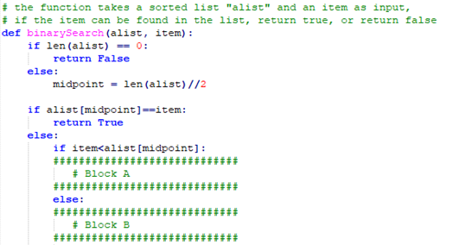

2) **MergeSort (5%+4%)**

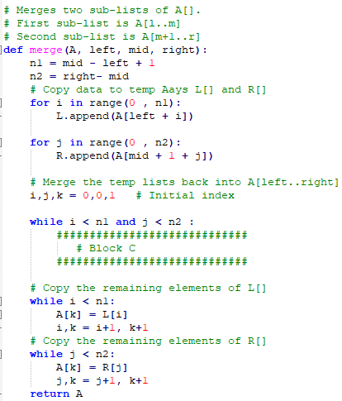

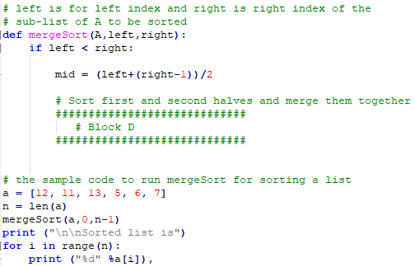

3) **Brackets Matched Checking (5%)**

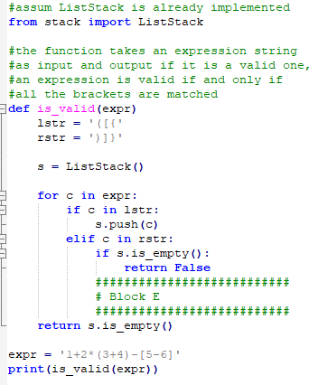

**Question 4. (10%)**

N-Queens problem is aiming to place N queens on a N*N chessboard such that no two queens can attack each other (i.e., no two queens are in the same row, same column, or same diagonal). There are many possible solutions. Please write a program that displays one such solution with a constraint that there is a queen at the r-th row and the c-th (both r and c are two numbers from 0 to N-1) column. If there is no such solution, print “None”. A sample output with N=8 and r,c=3,5 is shown as below.

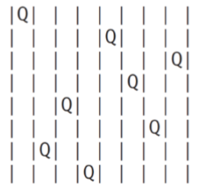

**Question 5. (10%)**

Implement a function that takes two strings as input and outputs its longest common sub-string. For example, the longest common sub-string of “input” and “output” is “put”. Please also give the time complexity analysis of your code.

**Question 6. (12%)**

Please implement a class named “myMatrix” whose details are shown as the left figure below. Note: 1) we use a list to store a matrix where each element in the list is also a list. 2) The file to store a matrix is in the formula as shown in the right figure below. Please also give a sample code how to use this class.

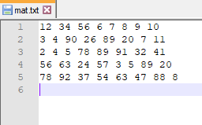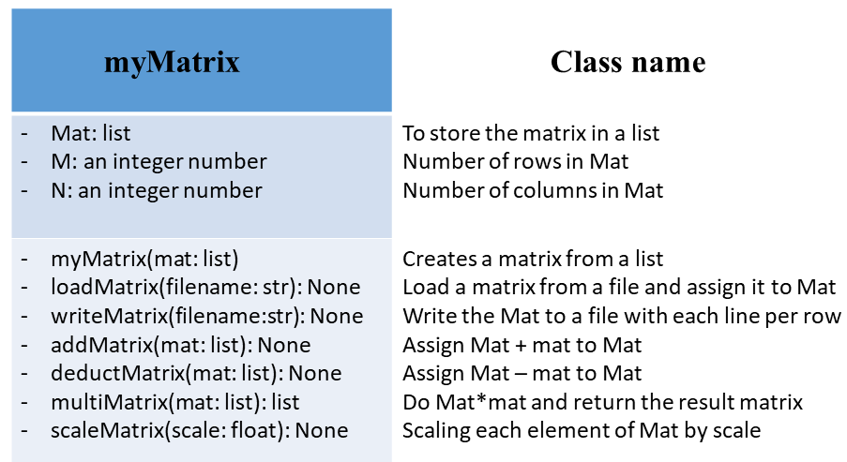

**END OF EXAMINATION**